BANGKOK-PATTAYA 4 DAY/3NIGHT

(Private)
Highlight: Song wat street art /Wat Arun / Tiger Park / Great grand destination with complimentary Ice Scream
Tour code: BP-04
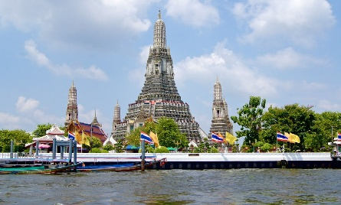
DAY 01 Flight arrive to BANGKOK Assemble at airport for flight to Bangkok,
This Photo by Unknown Author is licensed under CC BY-SA-NC
Wat Arun – Boat ride along the Chao Phraya River and visit the legendary
Song Wat Road, it’s a fascinating blend of history, street art, and café culture.
Bantadthong Night street food or Chiana Town (Dinner by own)

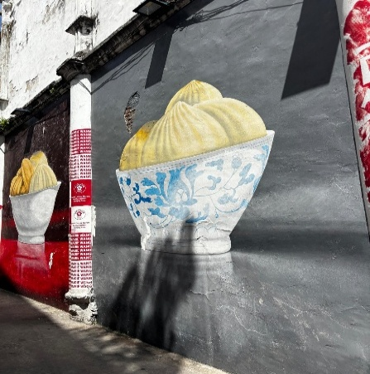
DAY 02 BANGKOK – PATTAYA (Breakfast / Lunch / Dinner)
- Pattaya Floating Market – See the day-to-day life of Thailand's residents while you walk around the aisles130- meter carved out an image of Buddha
- Tiger Park Pattaya and enjoy the exciting animal show
- Pattaya Viewpoint and Walking Street
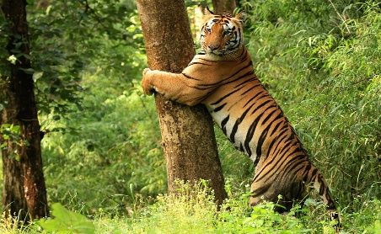
- Enjoy a stunning panoramic view of Pattaya Bay from the hilltop viewpoint, followed by an exciting evening stroll along the vibrant Pattaya Walking Street — famous for its nightlife, entertainment, and colorful atmosphere.
This Photo by Unknown Author is licensed under CC BY-SA
- Optional Cabaret show
DAY 03 PATTAYA – BANGKOK (Breakfast / Lunch/no)
- Great Grand Sweet Destination (Complementary ICE CREAM) after transfer to Bangkok
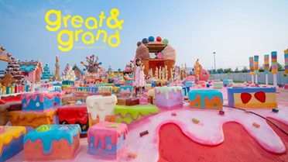
- Shopping at CENTRAL PARK (new shopping mall) or Platinum fashion mall
- Asiatiqure river front, (Dinner by own)
Day4: Bankgok -Depart : Hotel Breakfast, after Transfer to airport for your flight (Breakfast)

